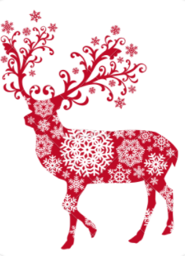Starters  
  
Homemade Cream Soup

Of The Day

Goats Cheese And Chive Bon Bons Walnut And Shallot Dressing

Traditional Smoked Salmon Plate, Red Onion And Caper With Dressed Leaves

Mains

Prime Irish Rib Eye Steak, Hand Cut Potato Fries And Pepper Sauce

Roast Stuffed Turkey And Ham, Herb Stuffing And Roast Gravy Jus

Grilled Fillet Of Hake with Champ Mashed Potato, Pear Onion And Pea Butter Sauce

*Vegetarian Dish On Request*

  
Desserts  
  
  
Baked Vanilla Cheesecake, Compote Of Mixed Berries

Warm Christmas Pudding With Brandy Anglaise Sauce

Rich Chocolate Biscuit Cake, Chocolate Ice-cream   
And Fresh Cream

****